Dr. Samindranath Mitra
Editor, Physical Review Letters

Dear Dr. Mitra,
We are writing regarding manuscript LG15054, “Charge tuning of nonresonant magnetoexciton phonon interactions in graphene, by Sebastian Rémi, Bennett Goldberg, and Anna Swan. The manuscript was submitted more than a month ago, and you alerted us on Friday that no reports are forthcoming and the process must restart. We urge you to move with all available haste for the following reasons:
Since our submission in late July, we have been told that three different groups around the world have essentially the same data that we do, and are in the very process of completing manuscripts and submitting them, if they have not already done so. I am sure you are familiar with the competitiveness of research and in particular in the graphene field, but this work also represents the singular achievement of the first author, a senior graduate student, and being scooped because of referees’ recalcitrance and procrastination would seriously and adversely affect his career opportunities.
We recommended the following referees in our initial submission, and these experts are also direct competitors, so if you have not asked them, we urge you to do so.

Andrea Ferrari | acf26@eng.cam.ac.uk | University of Cambridge, Cambridge
Marek Potemski | marek.potemski@lncmi.cnrs.fr | Laboratoire National des Champs Magnetiques Intenses (LNCMI), Grenoble
Junichiro Kono | kono@rice.edu | Rice University, Houston
Aron Pinczuk | ap359@columbia.edu | Columbia University, New York
Tony F. Heinz | tfh3@columbia.edu | Columbia University, New York
We also include the following additional recommendations, again, experts and competitors.

Gérard Martinez | Gerard.martinez@lncmi.cnrs.fr | LNCMI, Grenoble
Manfred Helm | M.Helm@hzdr.de | Direktor, Institut fur Ionenstrahlenphysik und Materialforschung, TU Dresden
Steven G. Louie | sglouie@berkeley.edu | University of California, Berkeley
Piotr Kossacki | Piotr.Kossacki@fuw.edu.pl | University of Warsaw
Dmitry Smirnov | smirnov@magnet.fsu.edu | National High Magnetic Field Laboratory
Finally, we would like to schedule a phone discussion with you for Tuesday. Could you send us your available times?
Sincerely,
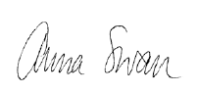

Anna Swan
Professor of Electrical and Computer Engineering
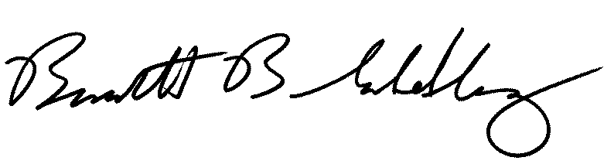
Professor of Physics

Bennett Goldberg
Professor of Physics, and Professor of Biomedical and Electrical and Computer Engineering

